**Introduction**

The rapid advancements in Generative AI have opened new avenues for personalized and interactive educational tools. This report explores the application of ChatGPT, a state-of-the-art language model, in simulating a chatbot to assist students in solving problems and enhancing their learning experience. Specifically, the report evaluates ChatGPT's ability to generate a detailed learning profile, design a tailored study plan, and simulate an interactive chatbot for solving math and physics problems.

The project focuses on a hypothetical 10th-grade student, Alex, who aims to strengthen their skills in algebra and physics. ChatGPT was tasked with creating a personalized educational framework that included:

1. Generating a comprehensive learning profile.
2. Designing a 4-week study plan.
3. Developing quizzes tailored to Alex’s academic level.
4. Simulating a chatbot that provides step-by-step guidance and encouragement while solving problems.

Each stage of the assignment was assessed for its effectiveness, clarity, and relevance to Alex’s learning objectives. The report highlights ChatGPT’s strengths, such as its ability to provide structured and interactive responses, and discusses opportunities for enhancement to further improve its educational capabilities.

By analyzing ChatGPT's performance across multiple iterations, this report aims to demonstrate the potential of Generative AI as a versatile educational tool while identifying areas for refinement to maximize its impact in real-world learning environments.

**Step 1: Set Up Your Environment**

Make sure you have the openai library installed:

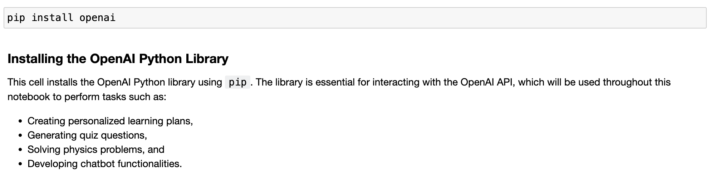

**Step 2: Initialize OpenAI API authentication key**

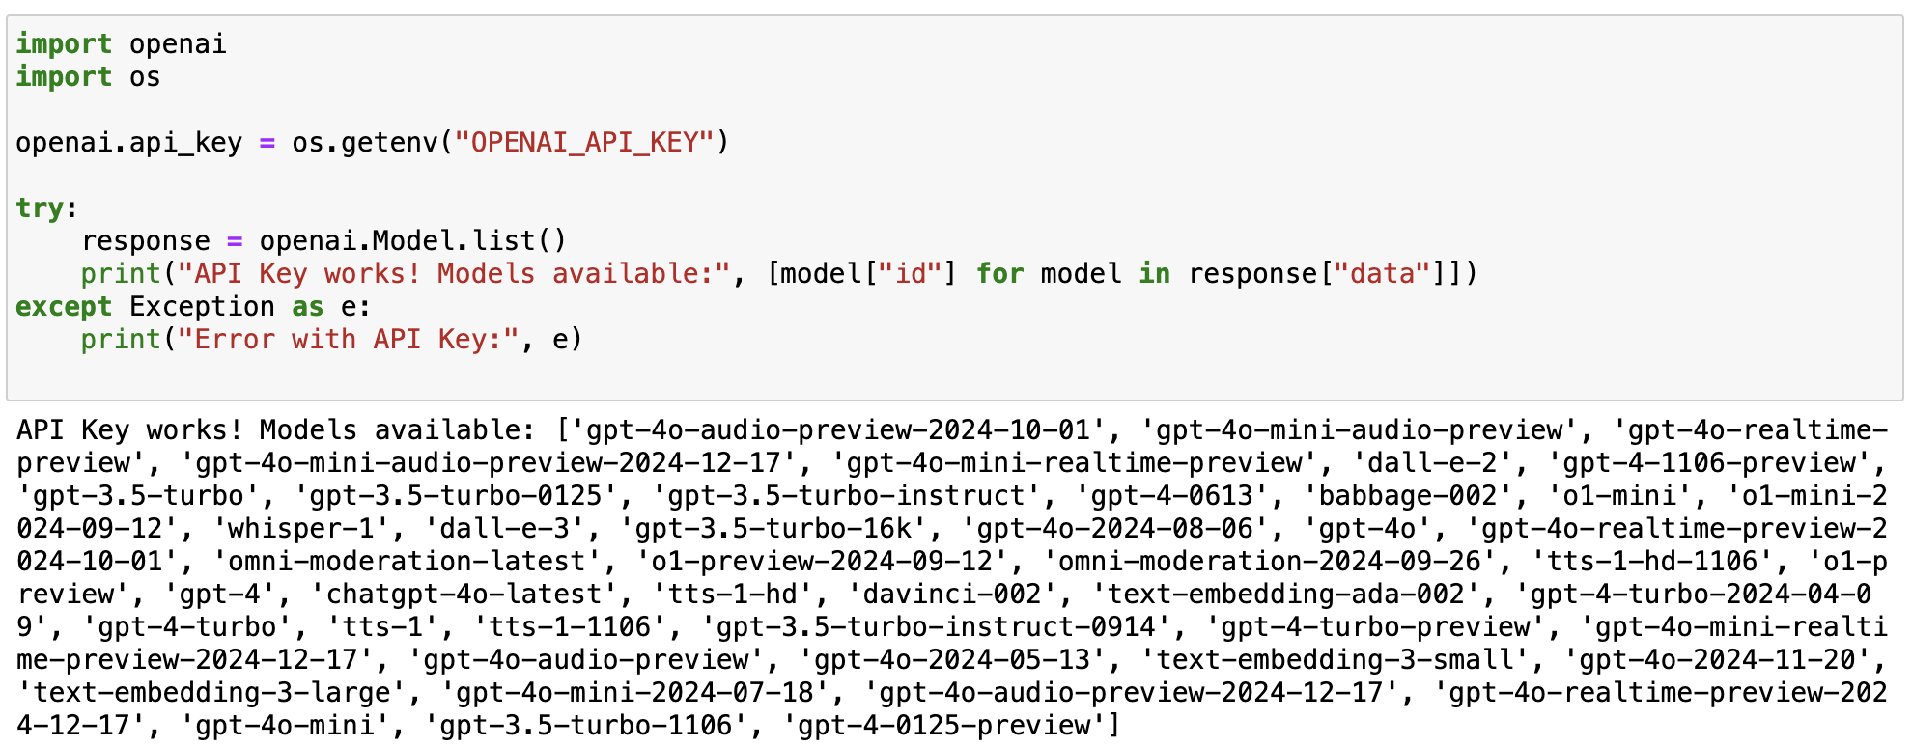

**Step 3: Initialize Student Profile**

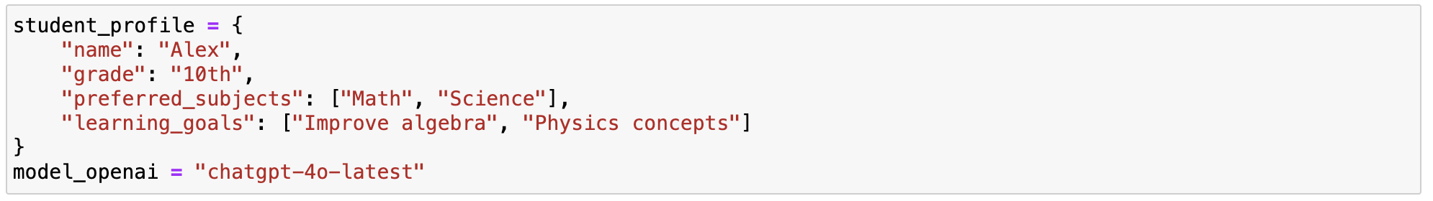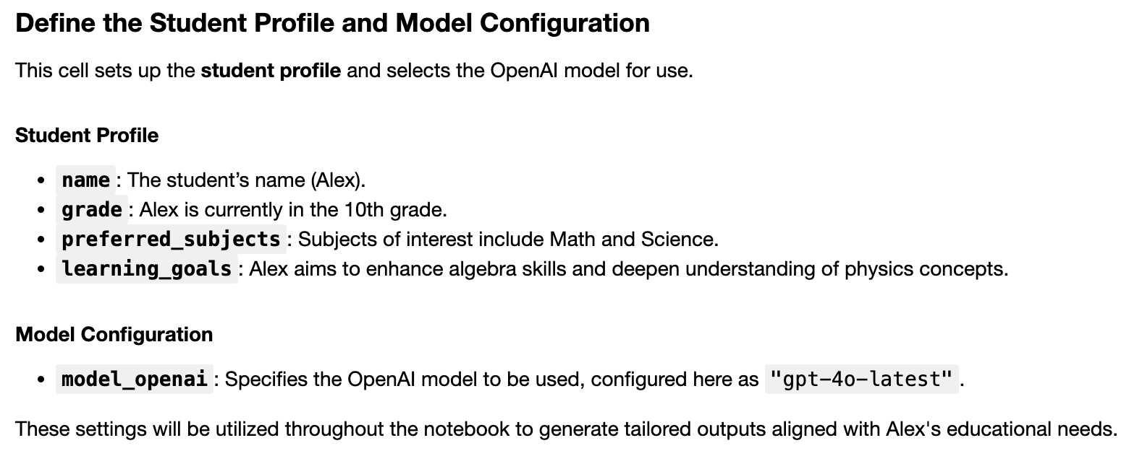

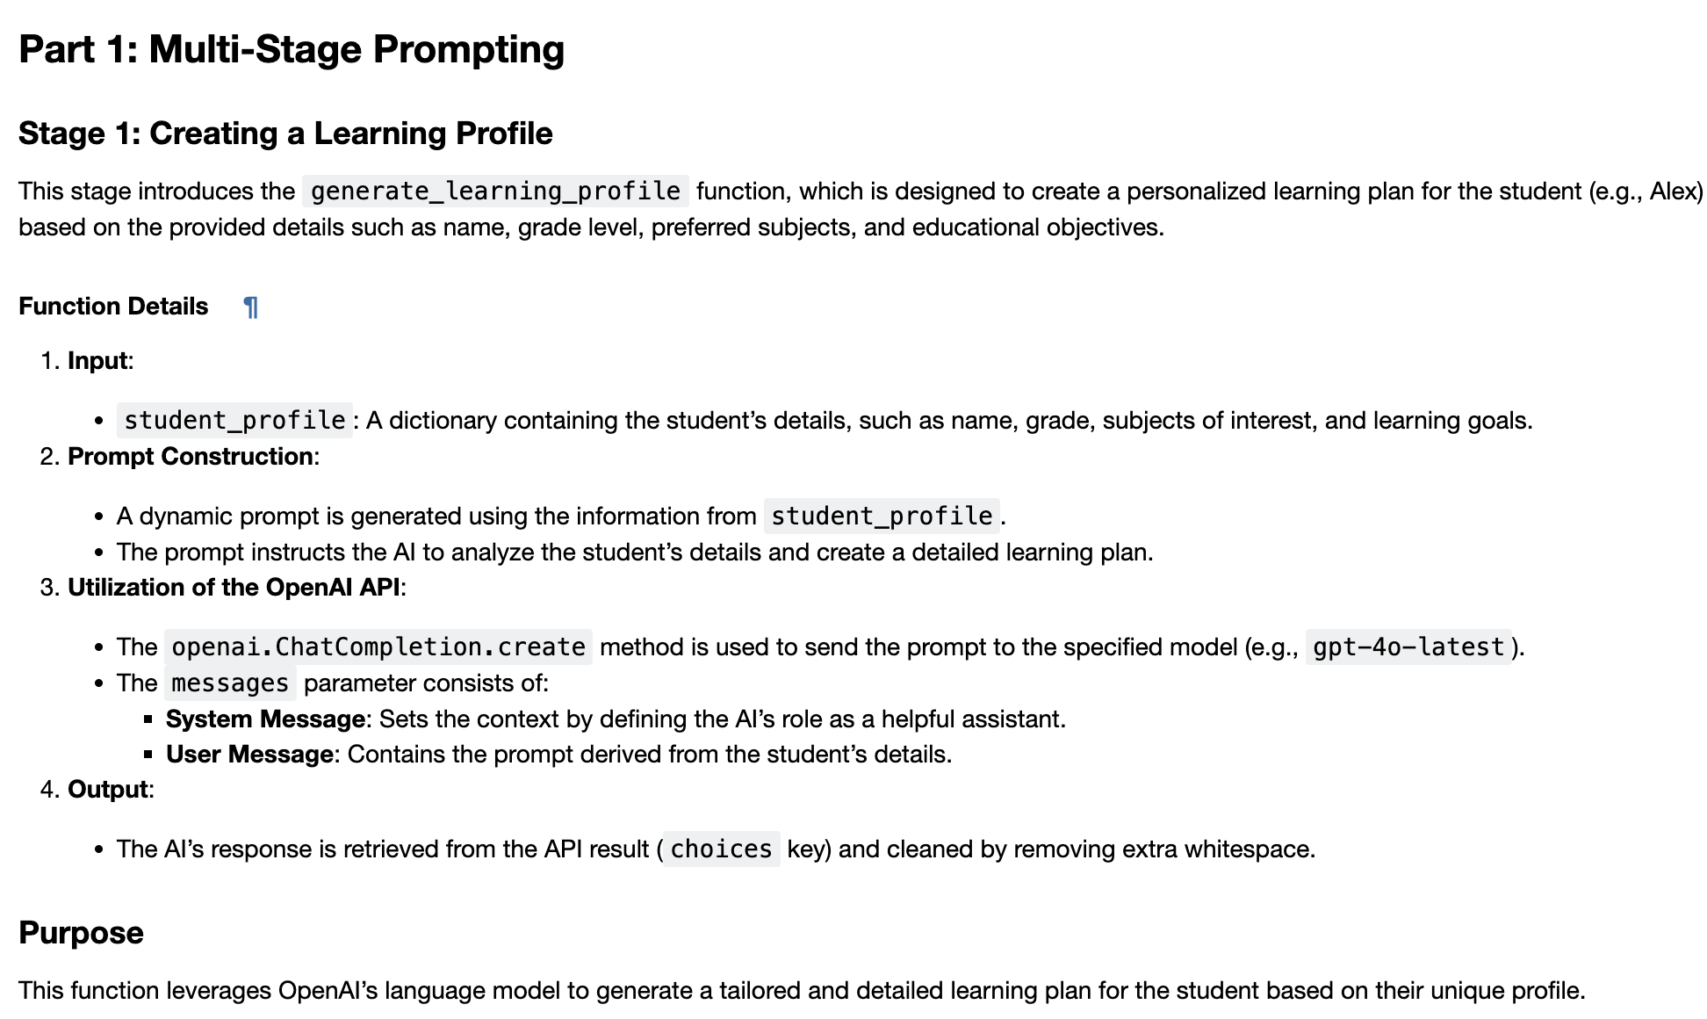

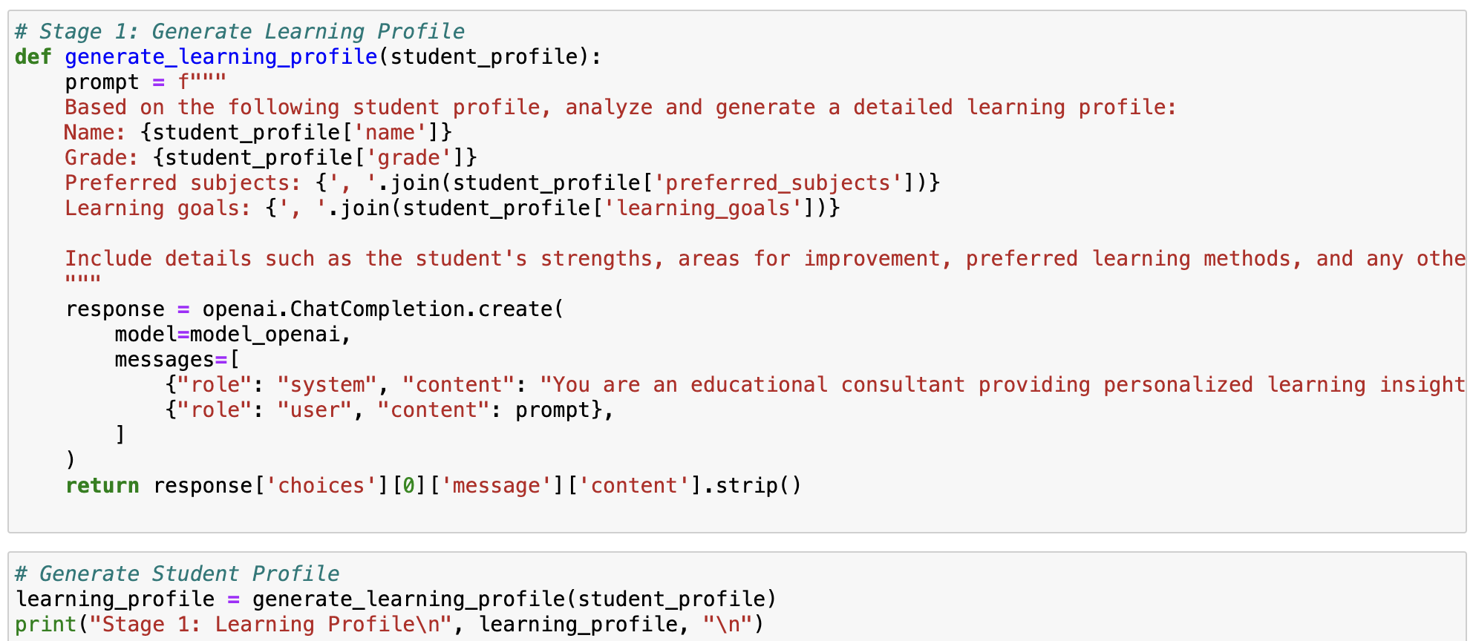

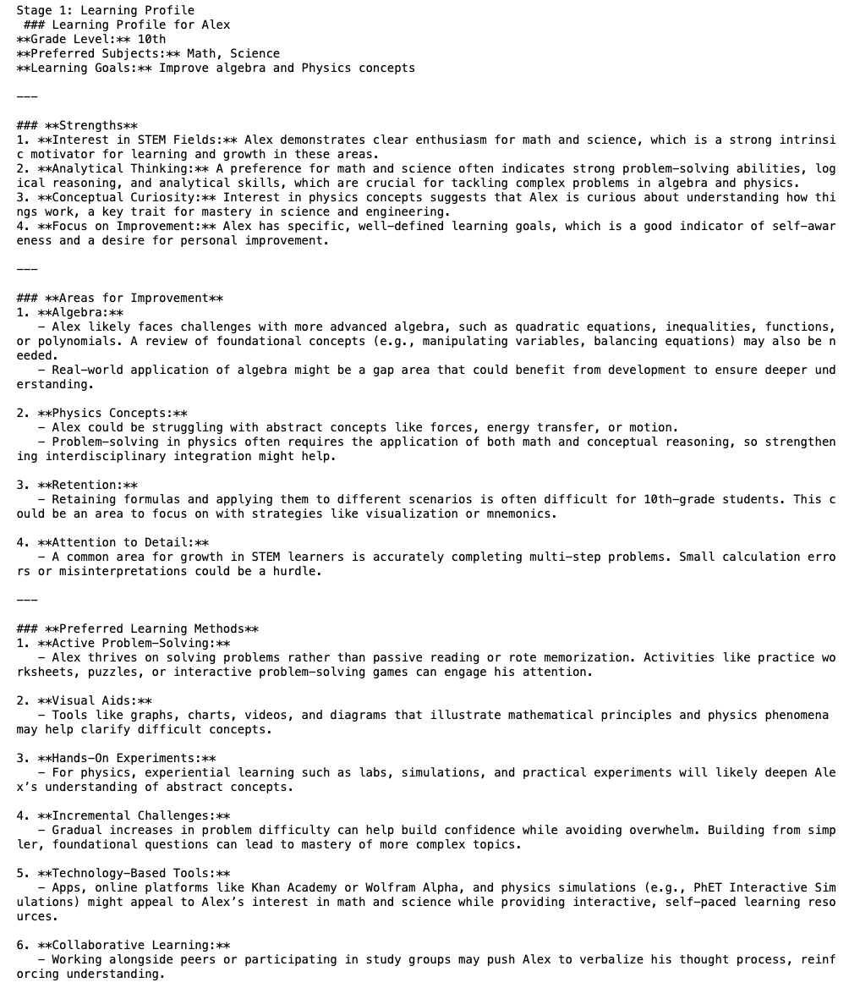

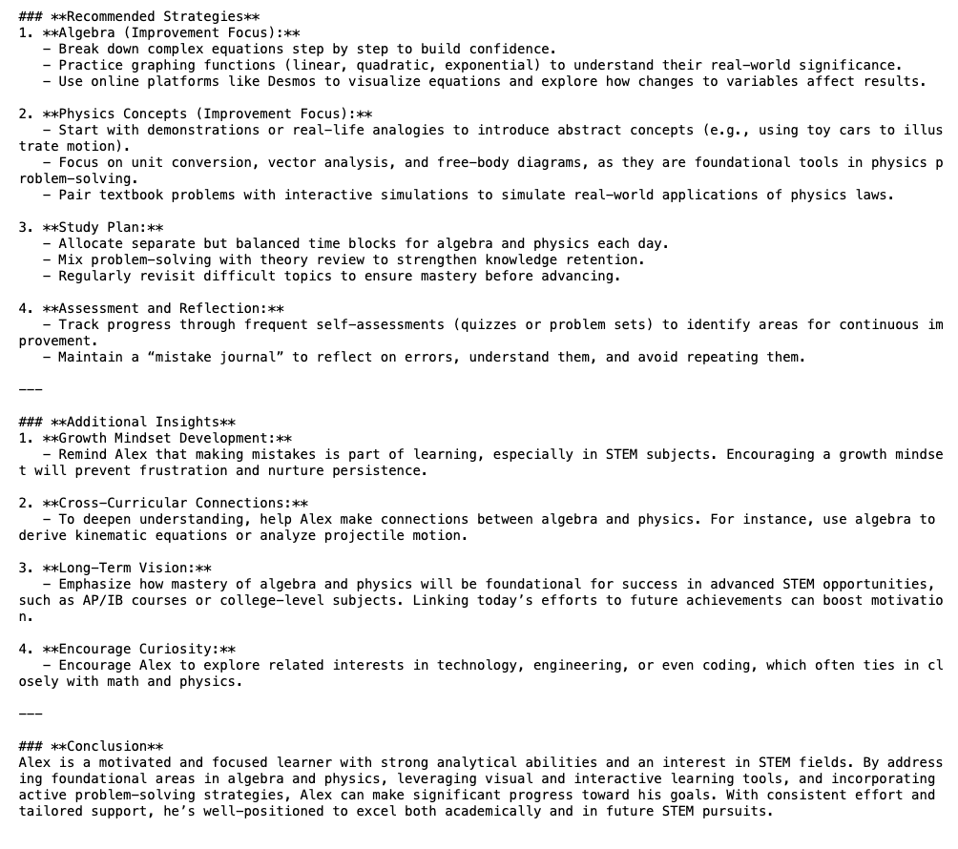

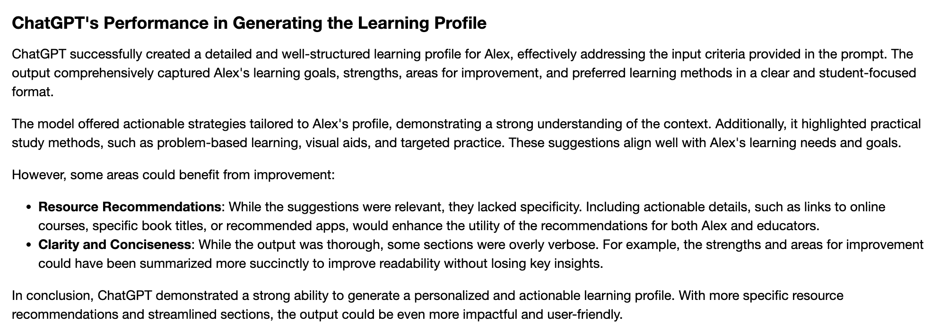

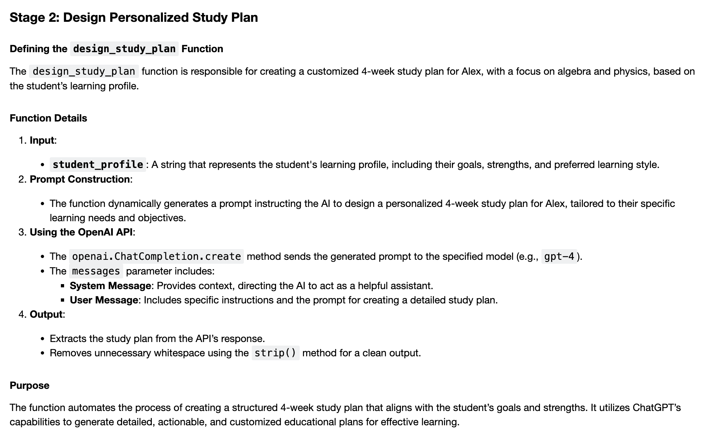

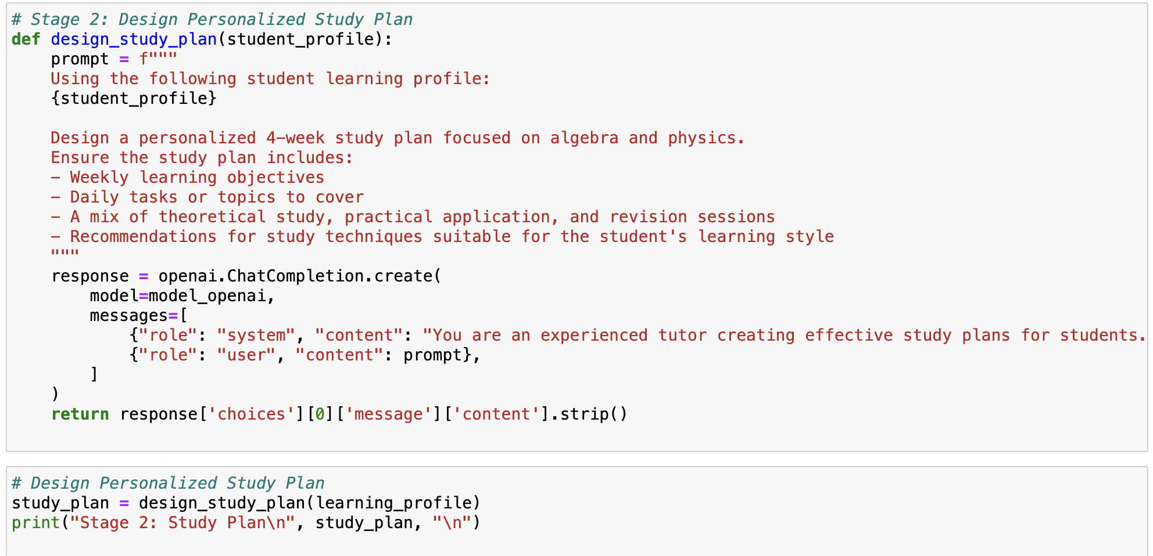

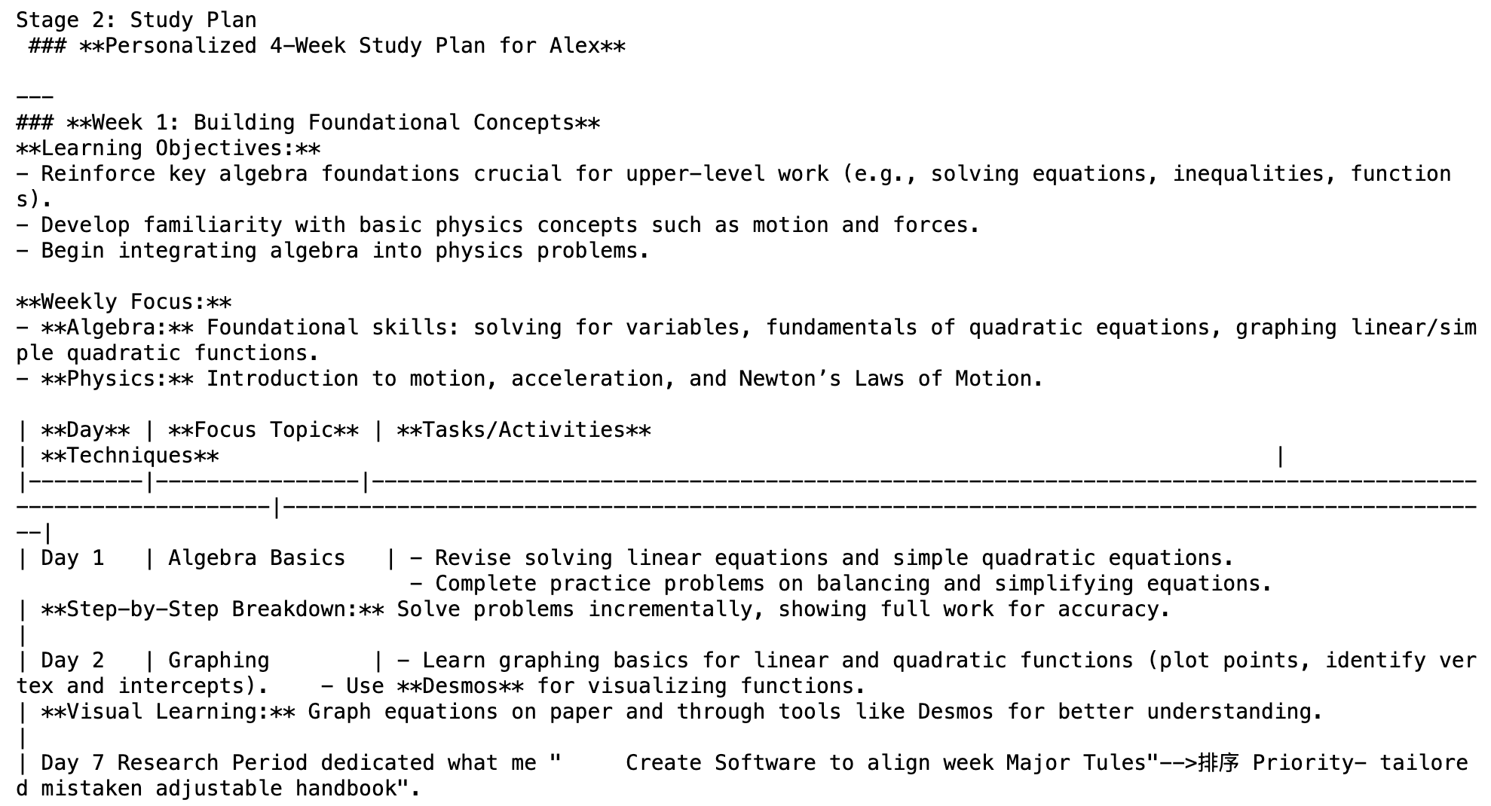

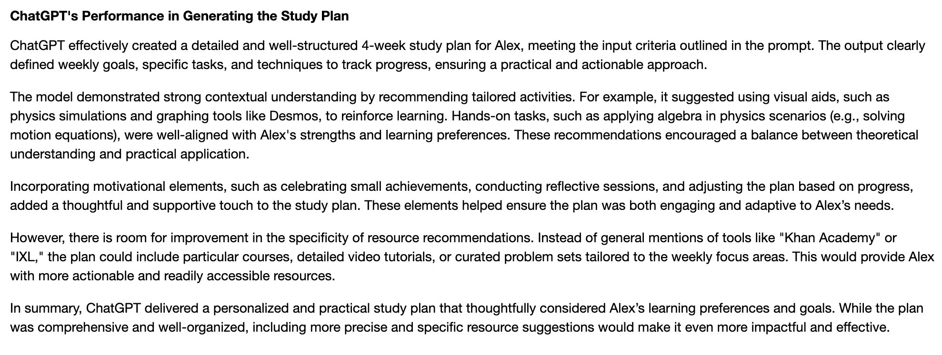

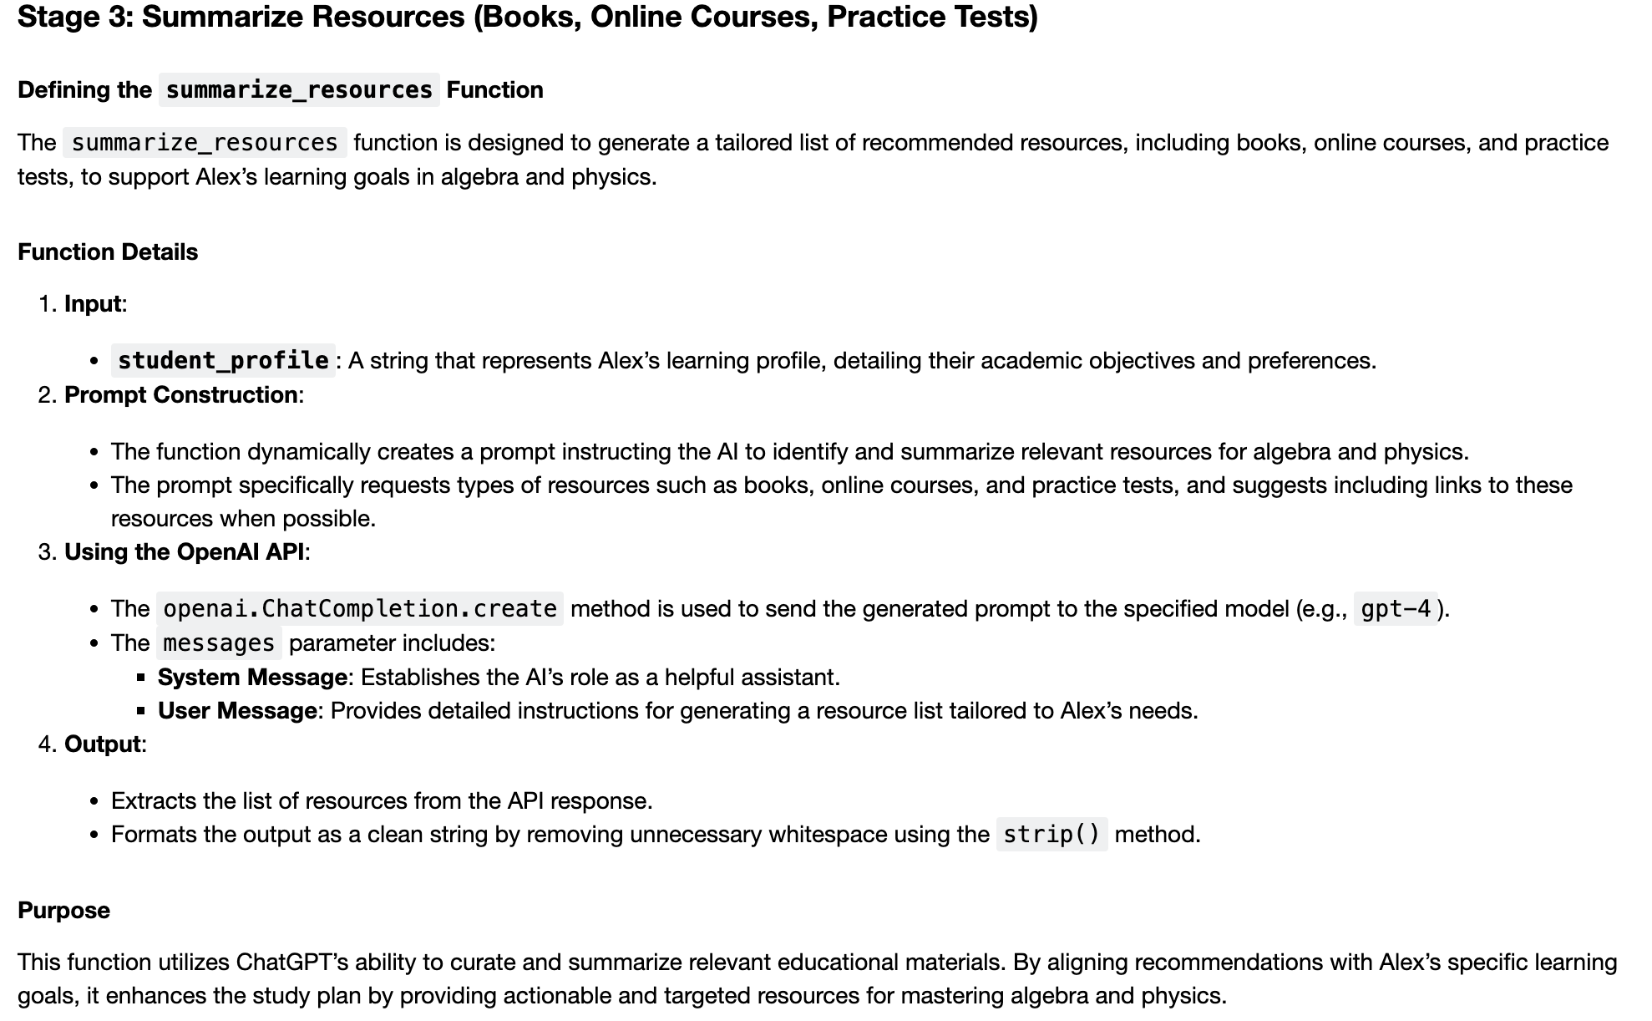



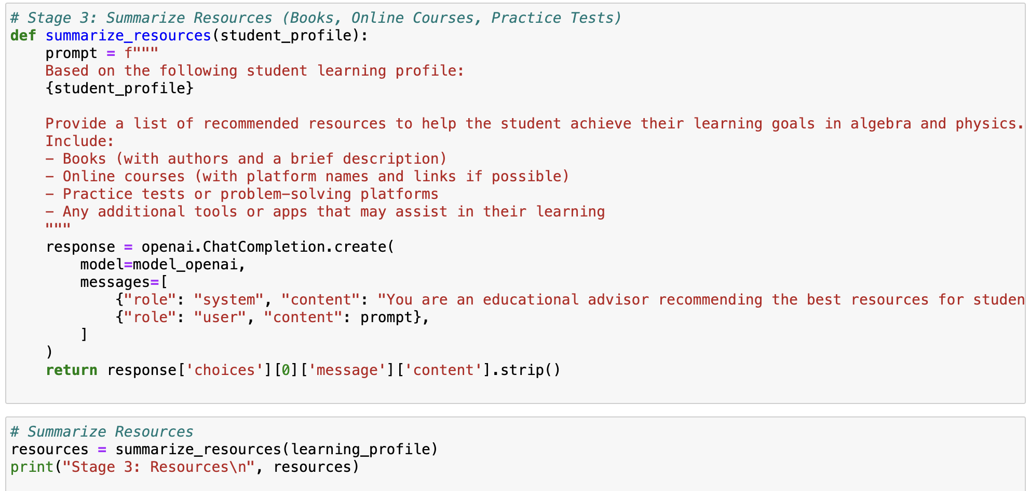

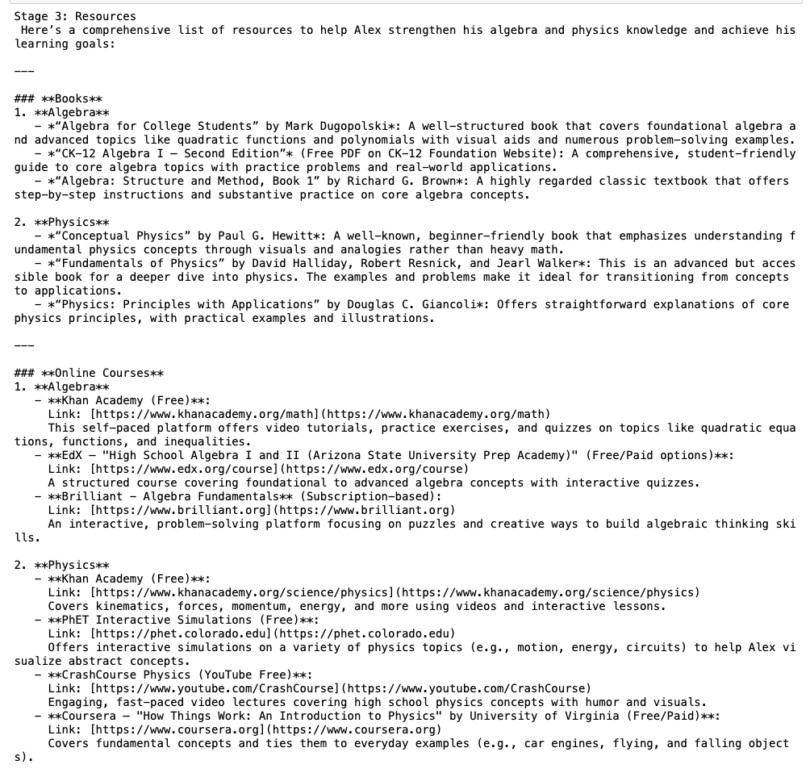

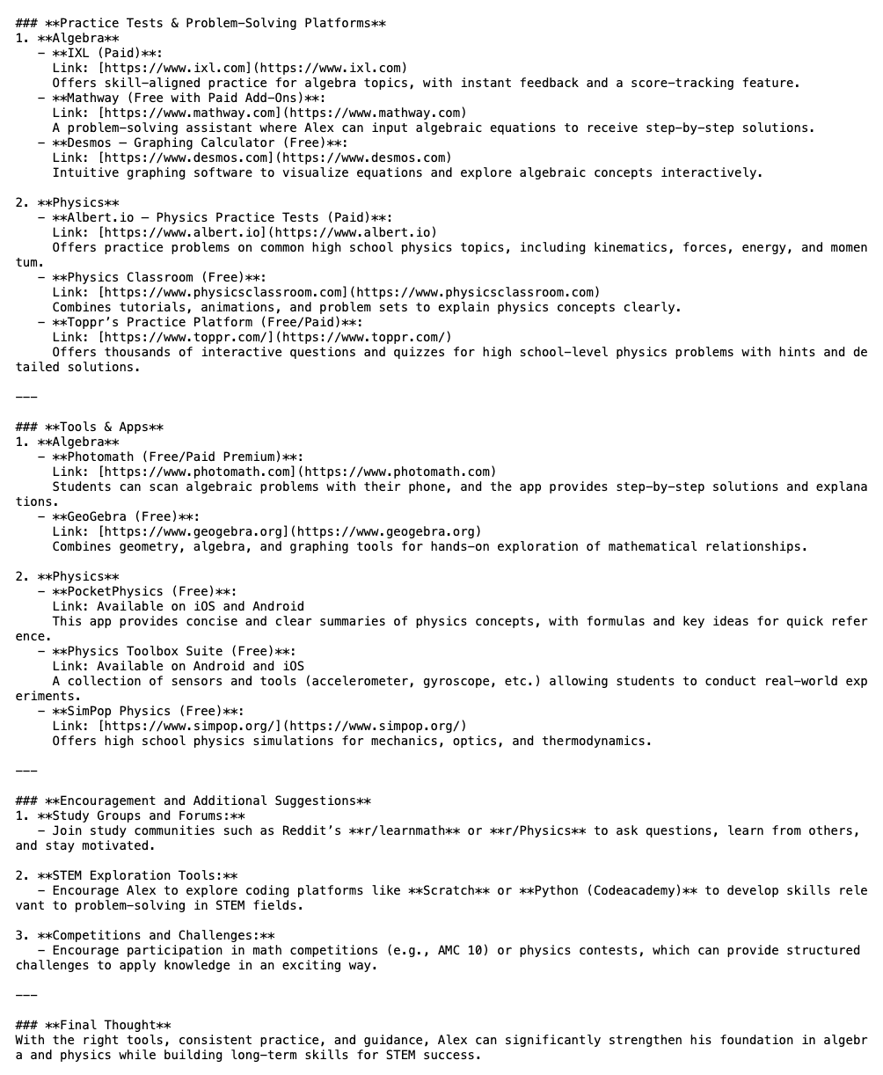

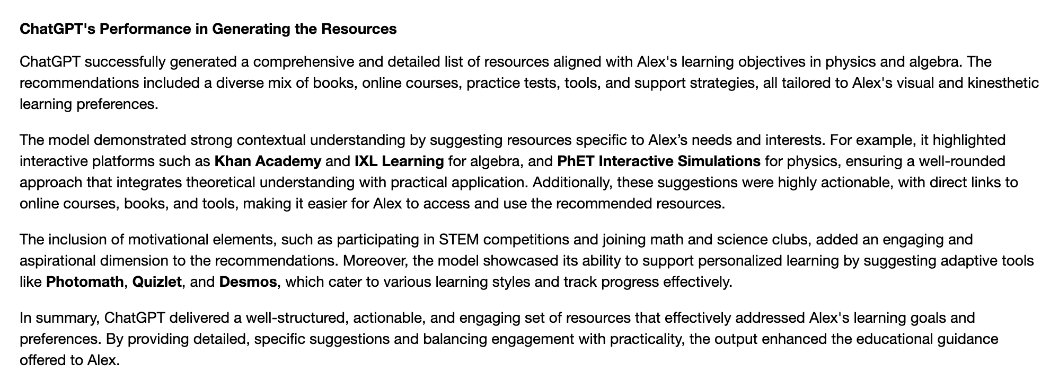

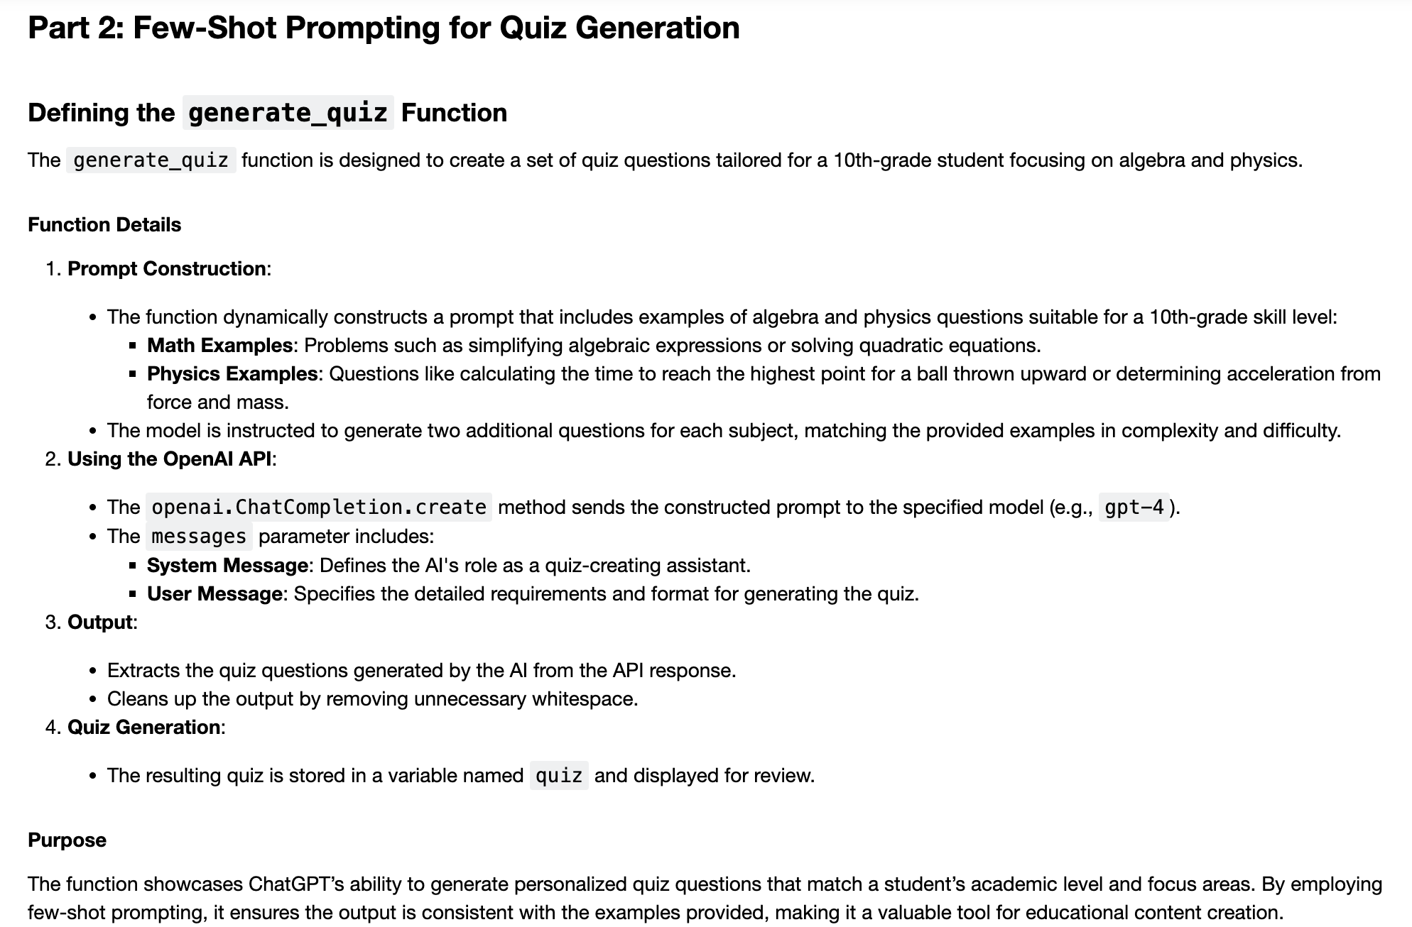

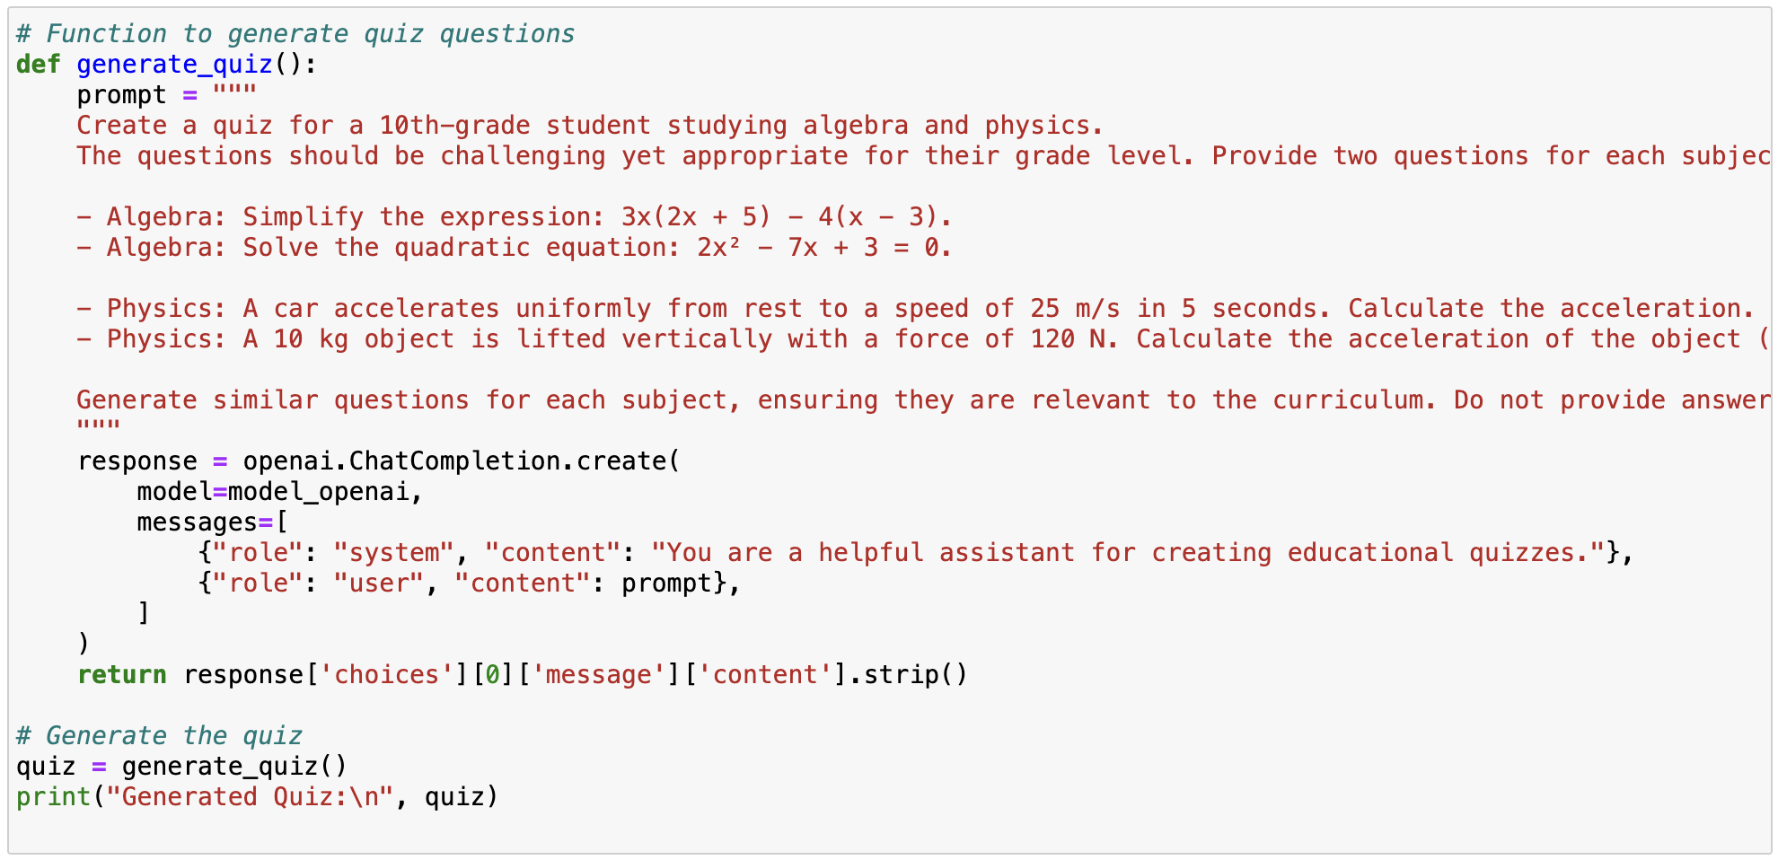

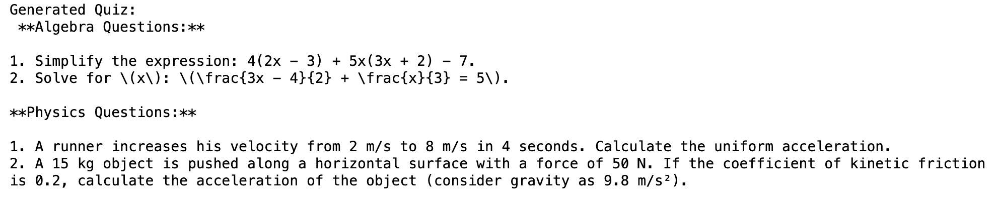

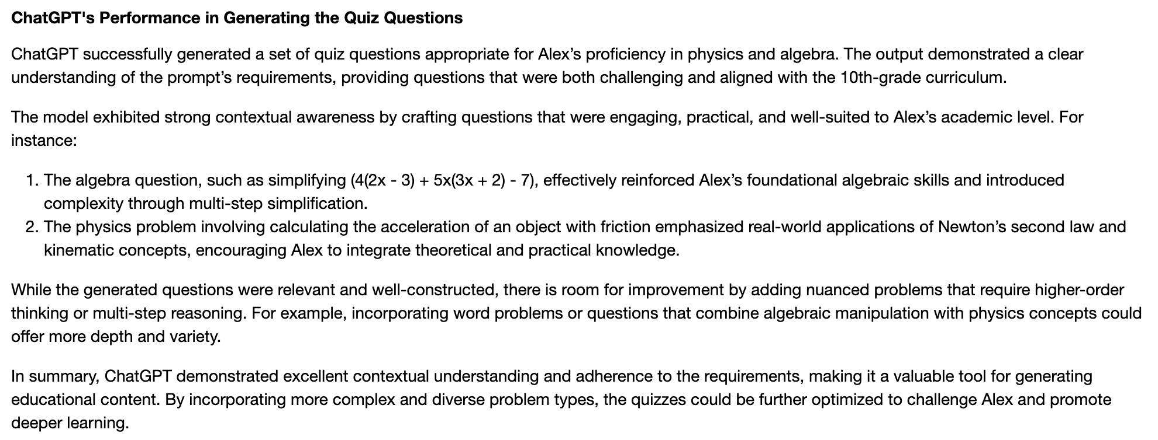

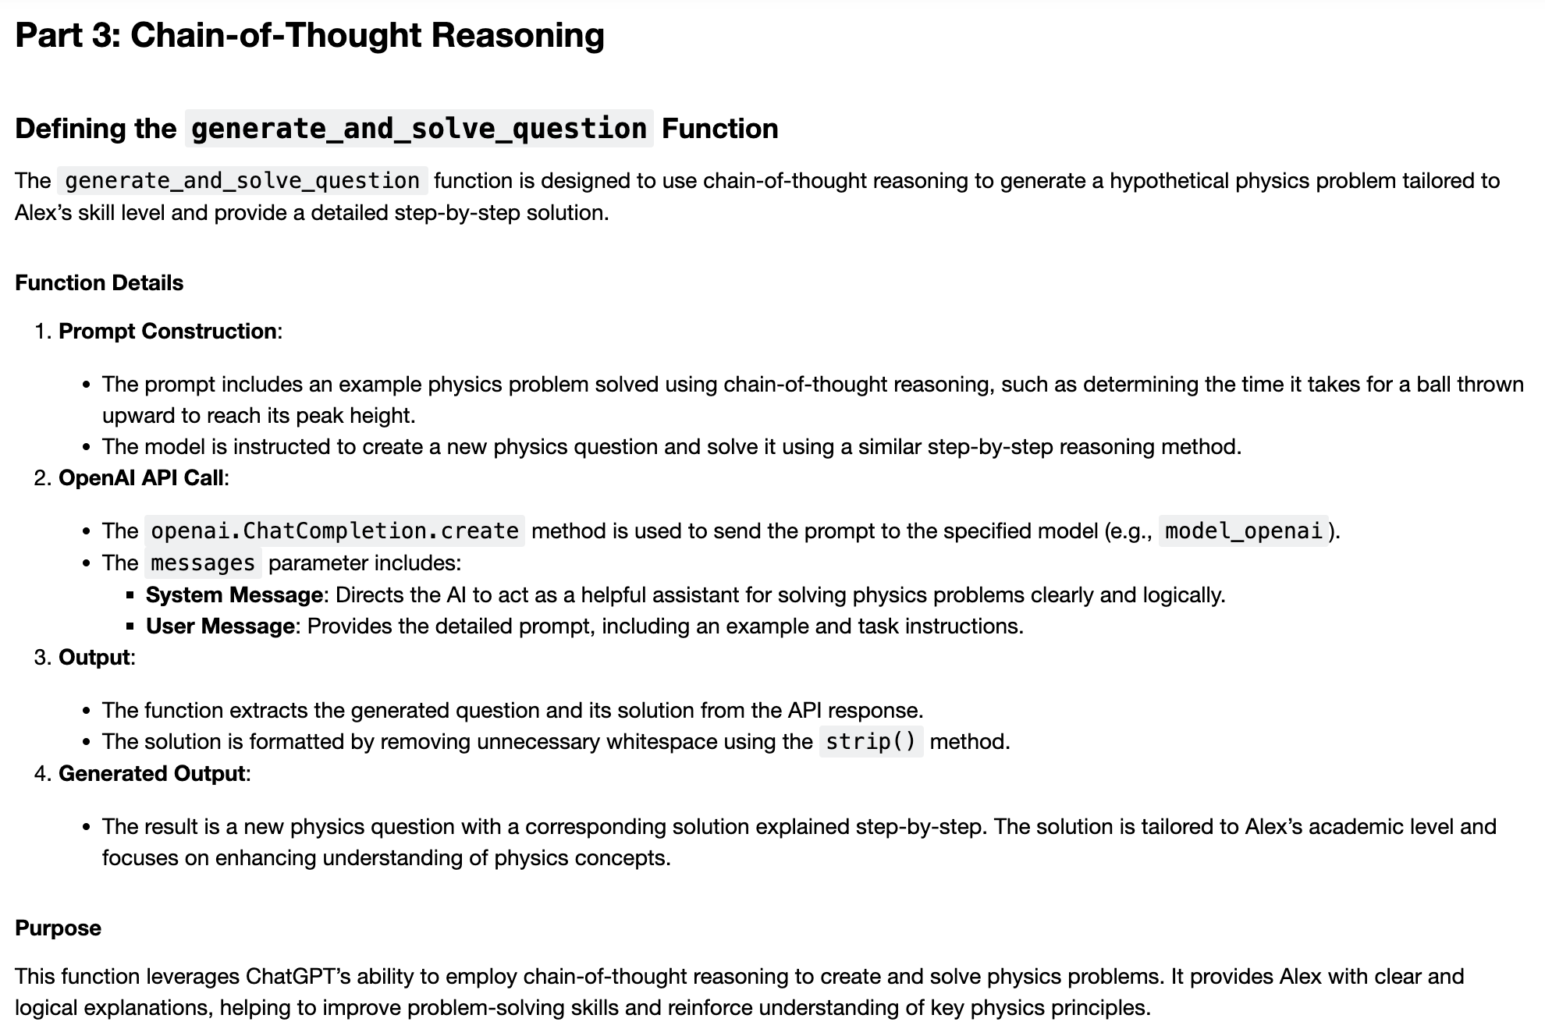

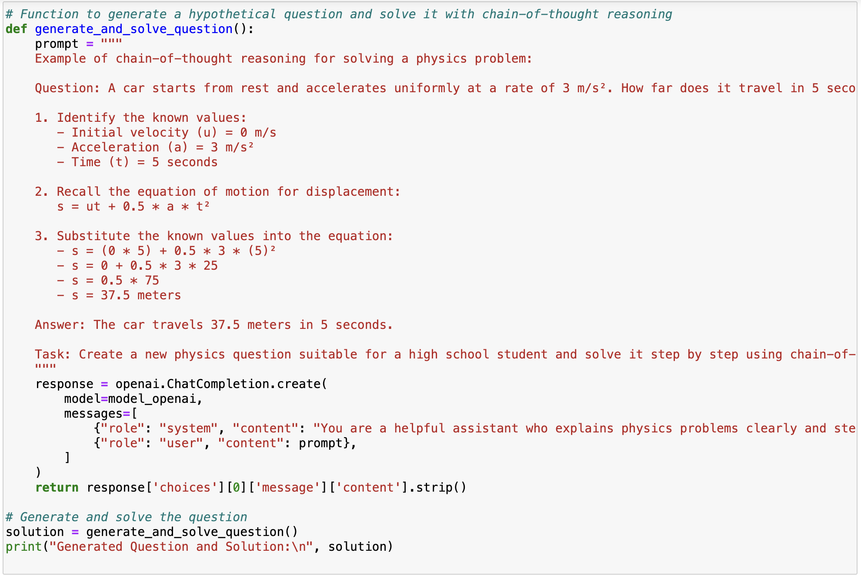

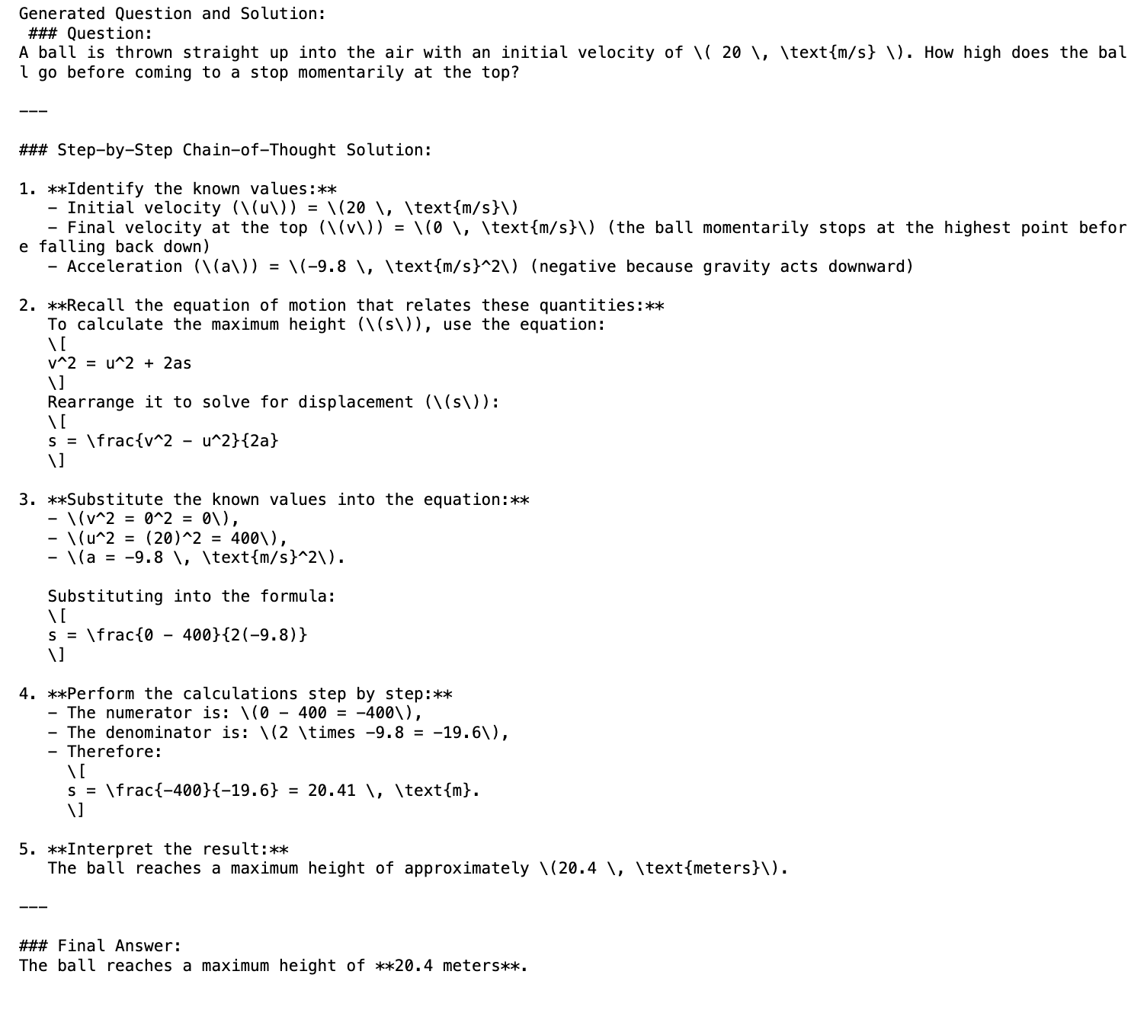

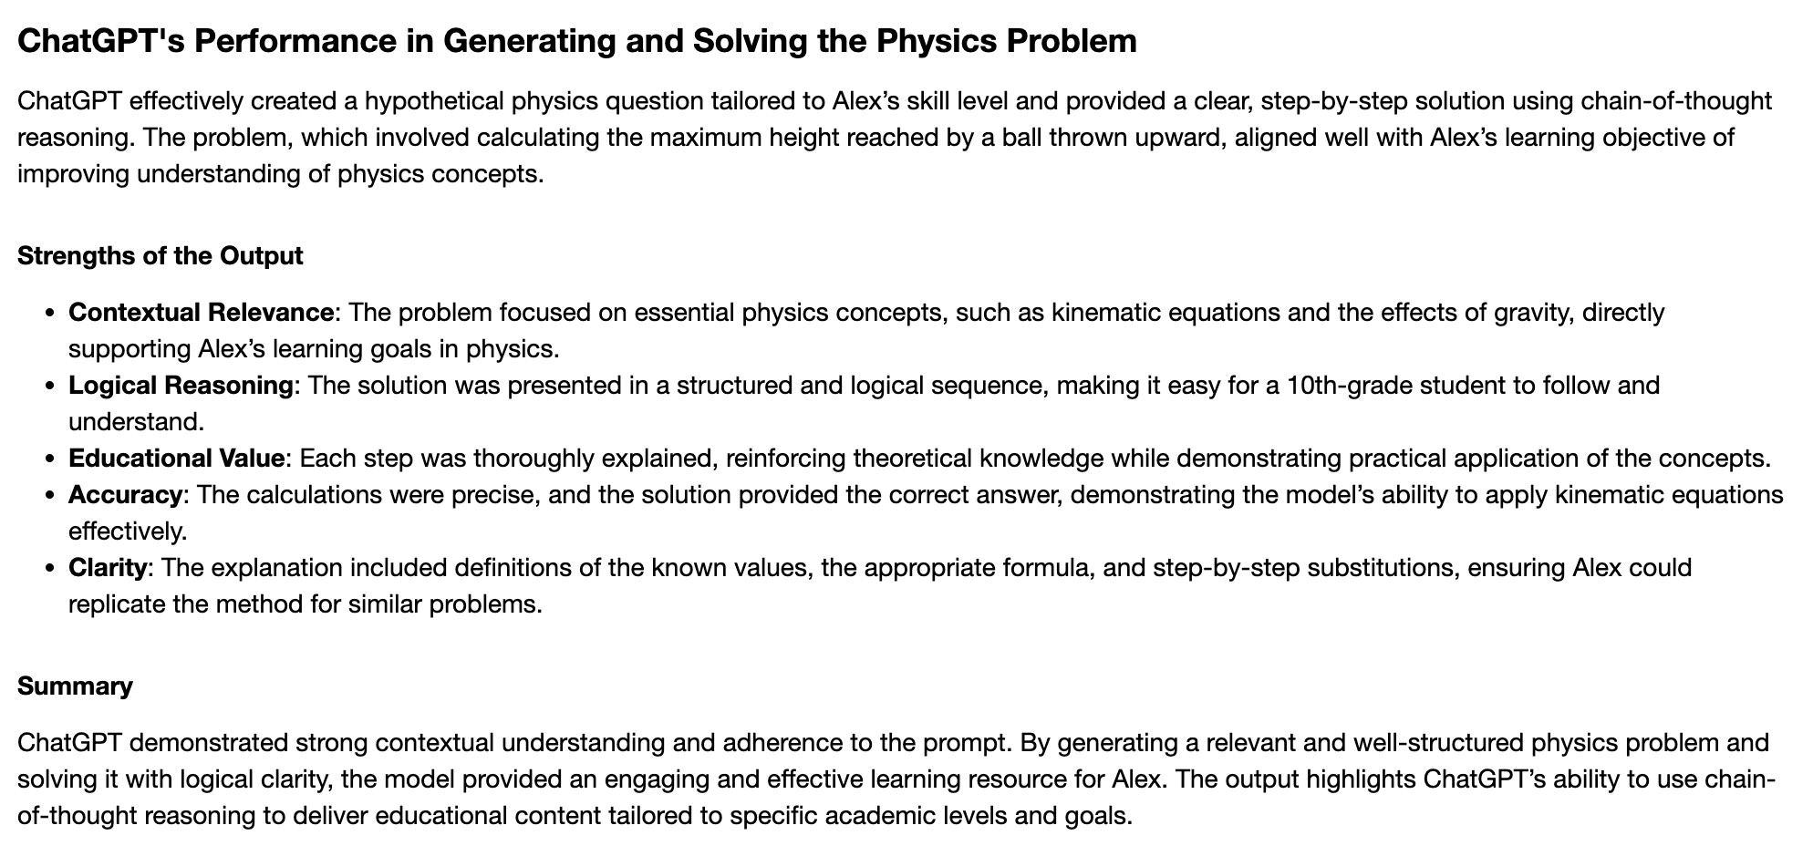

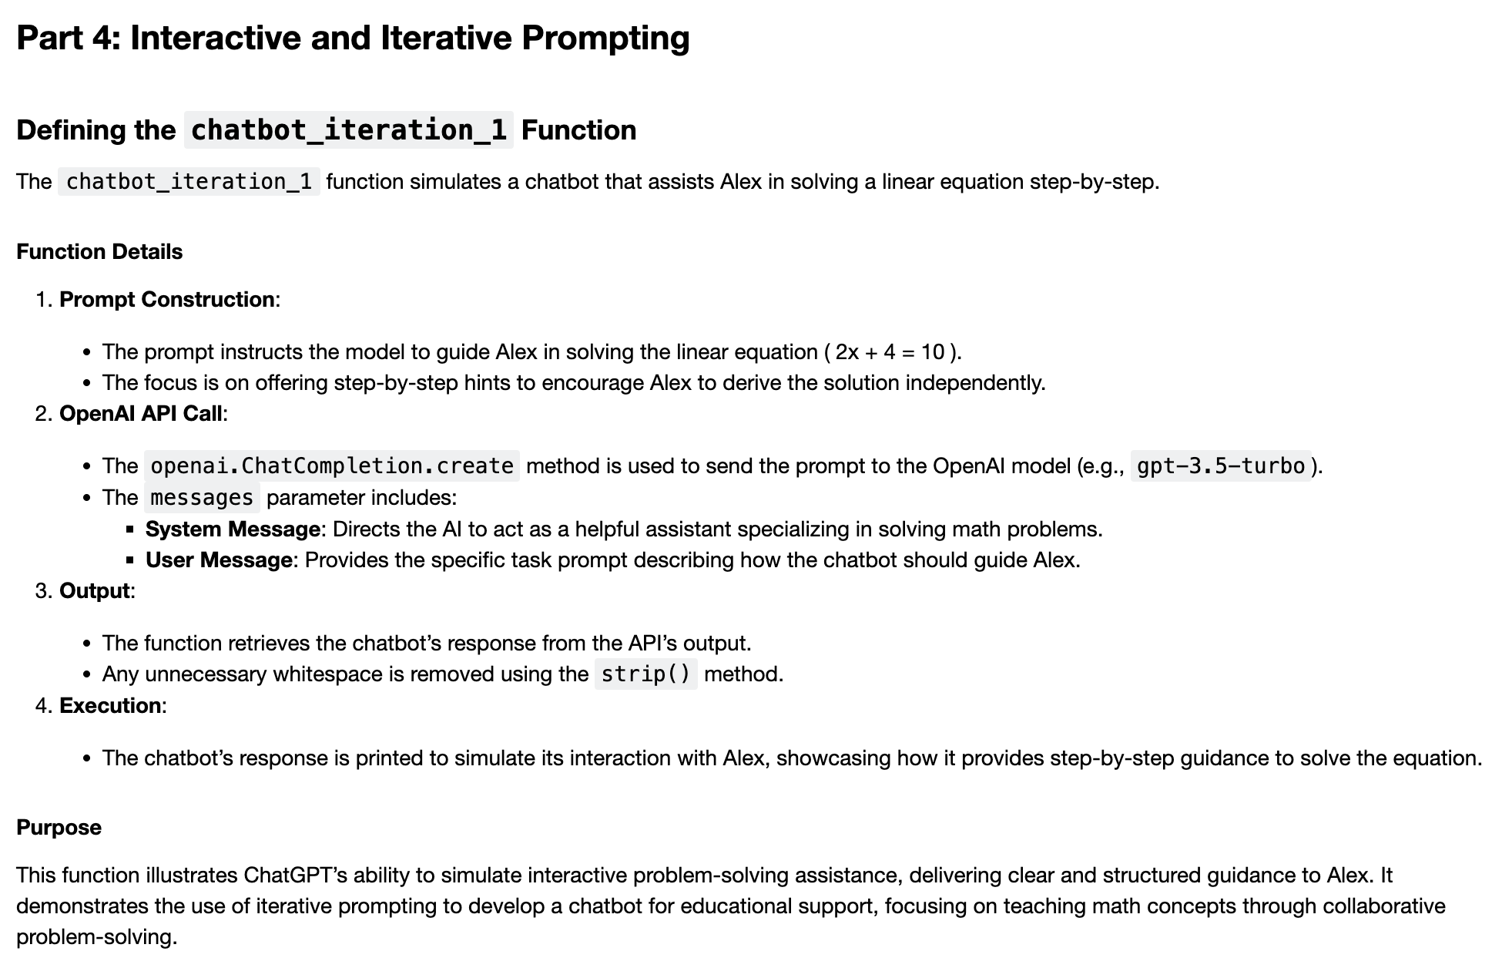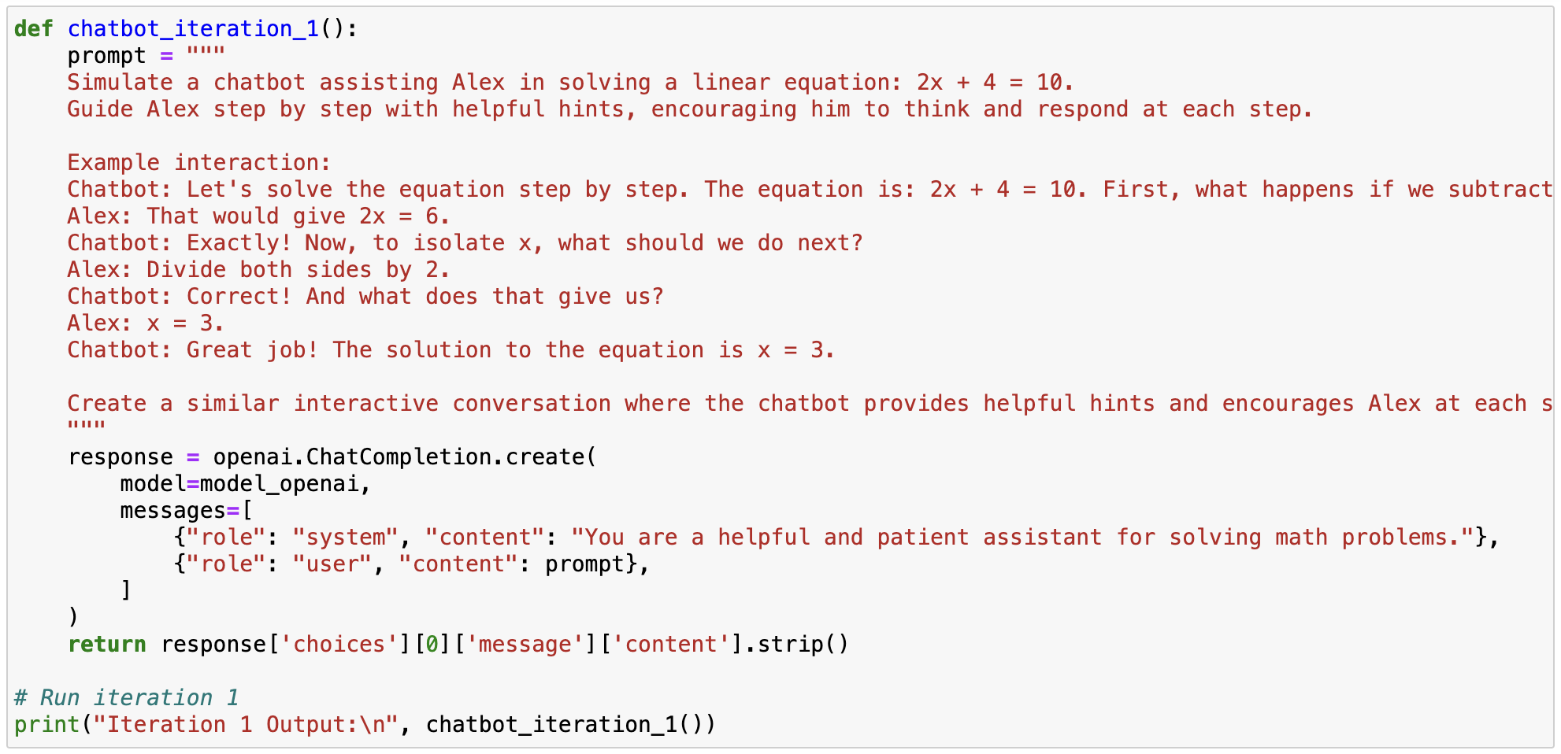

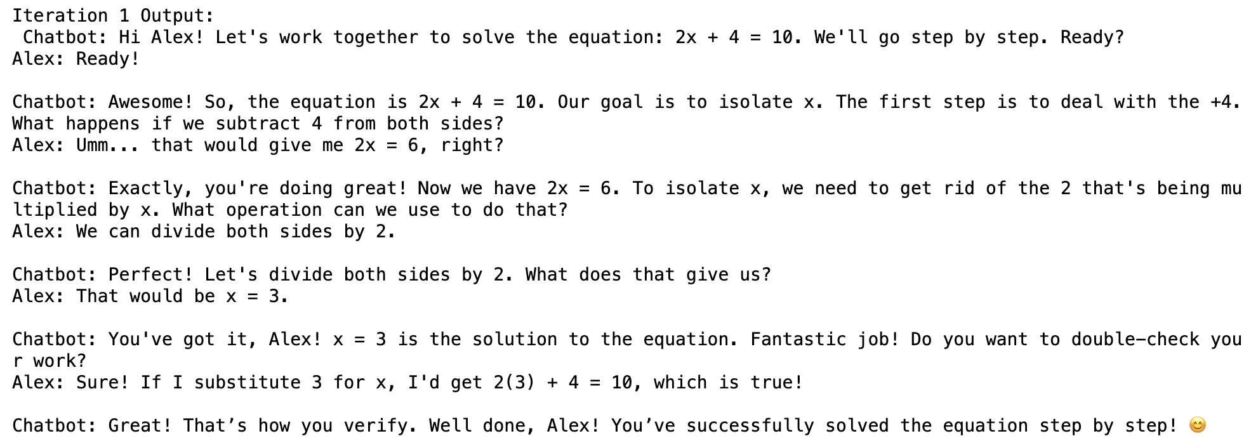

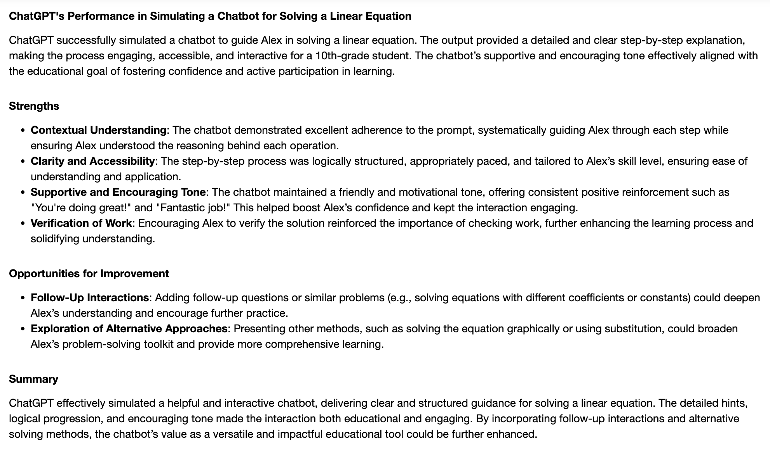

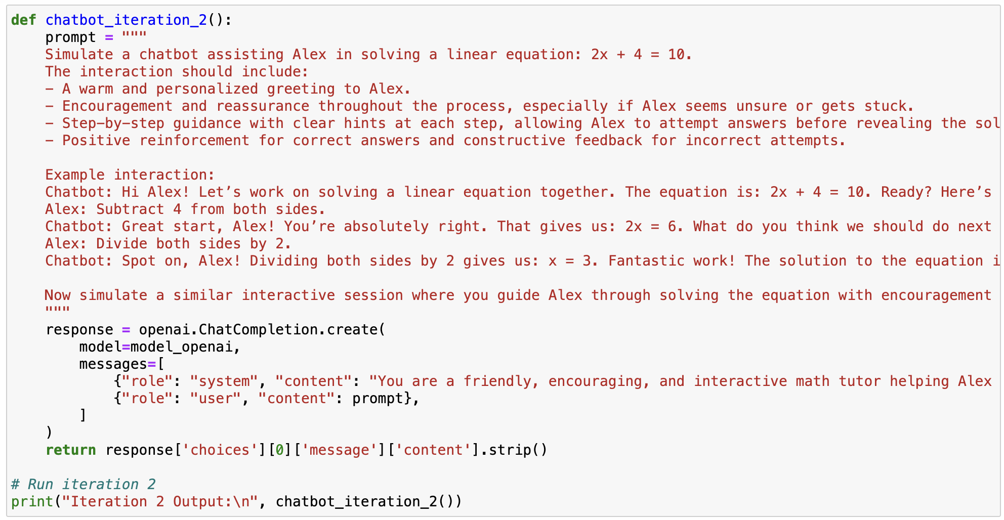

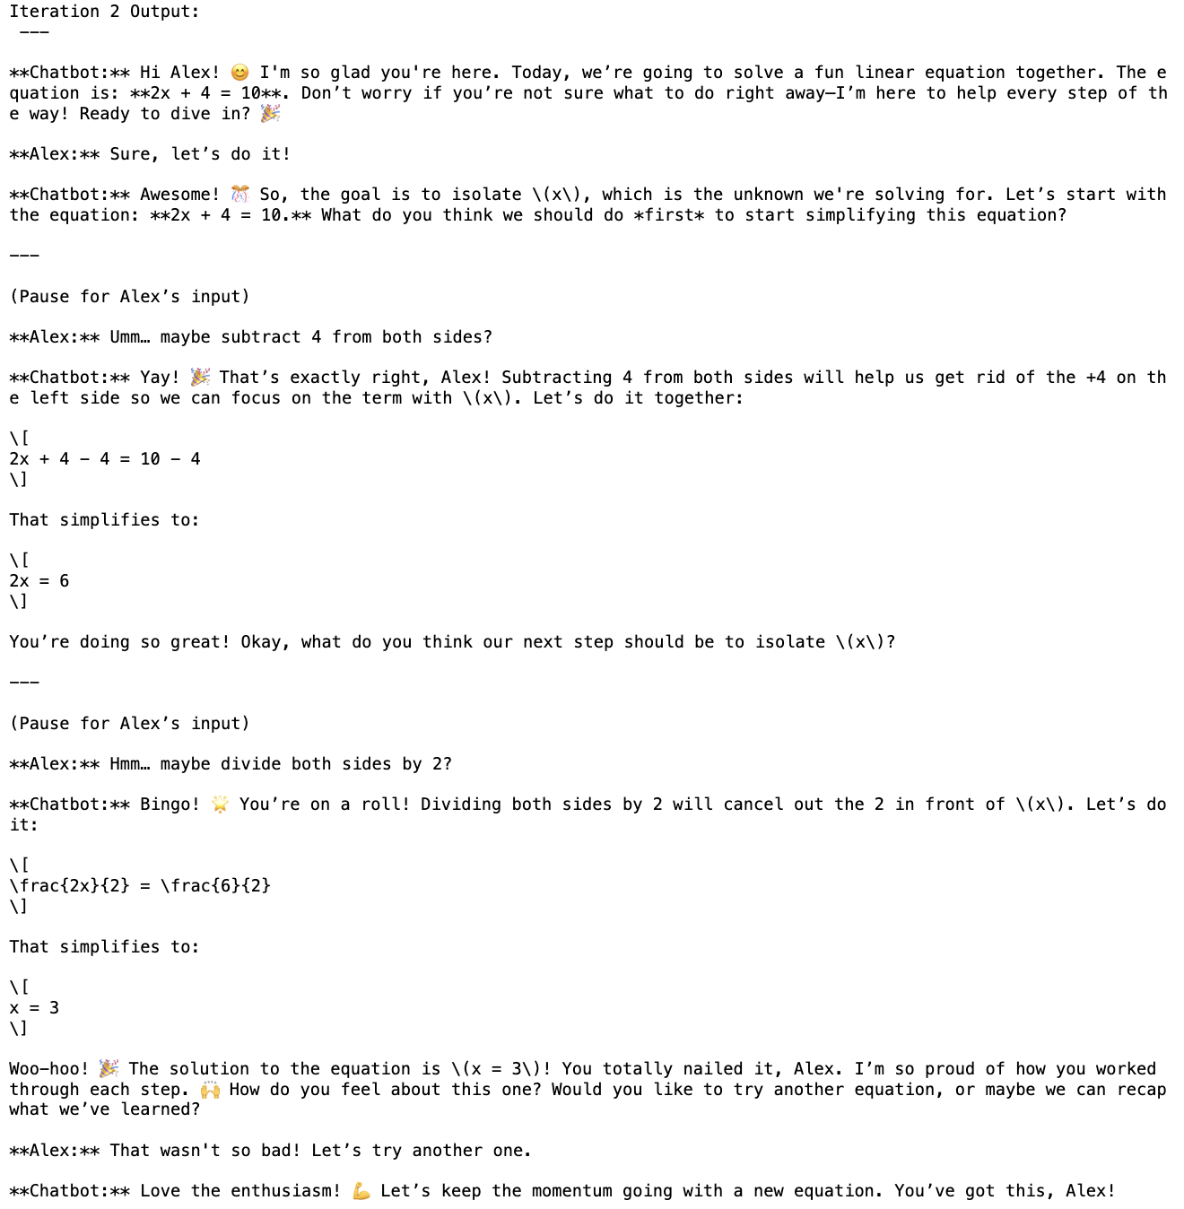

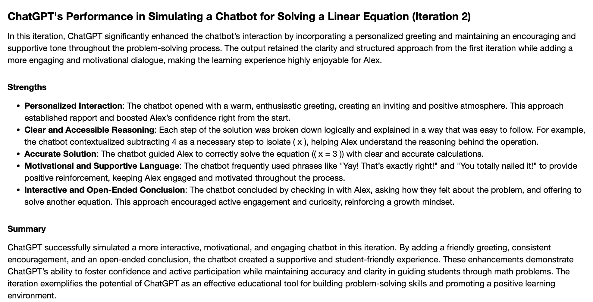

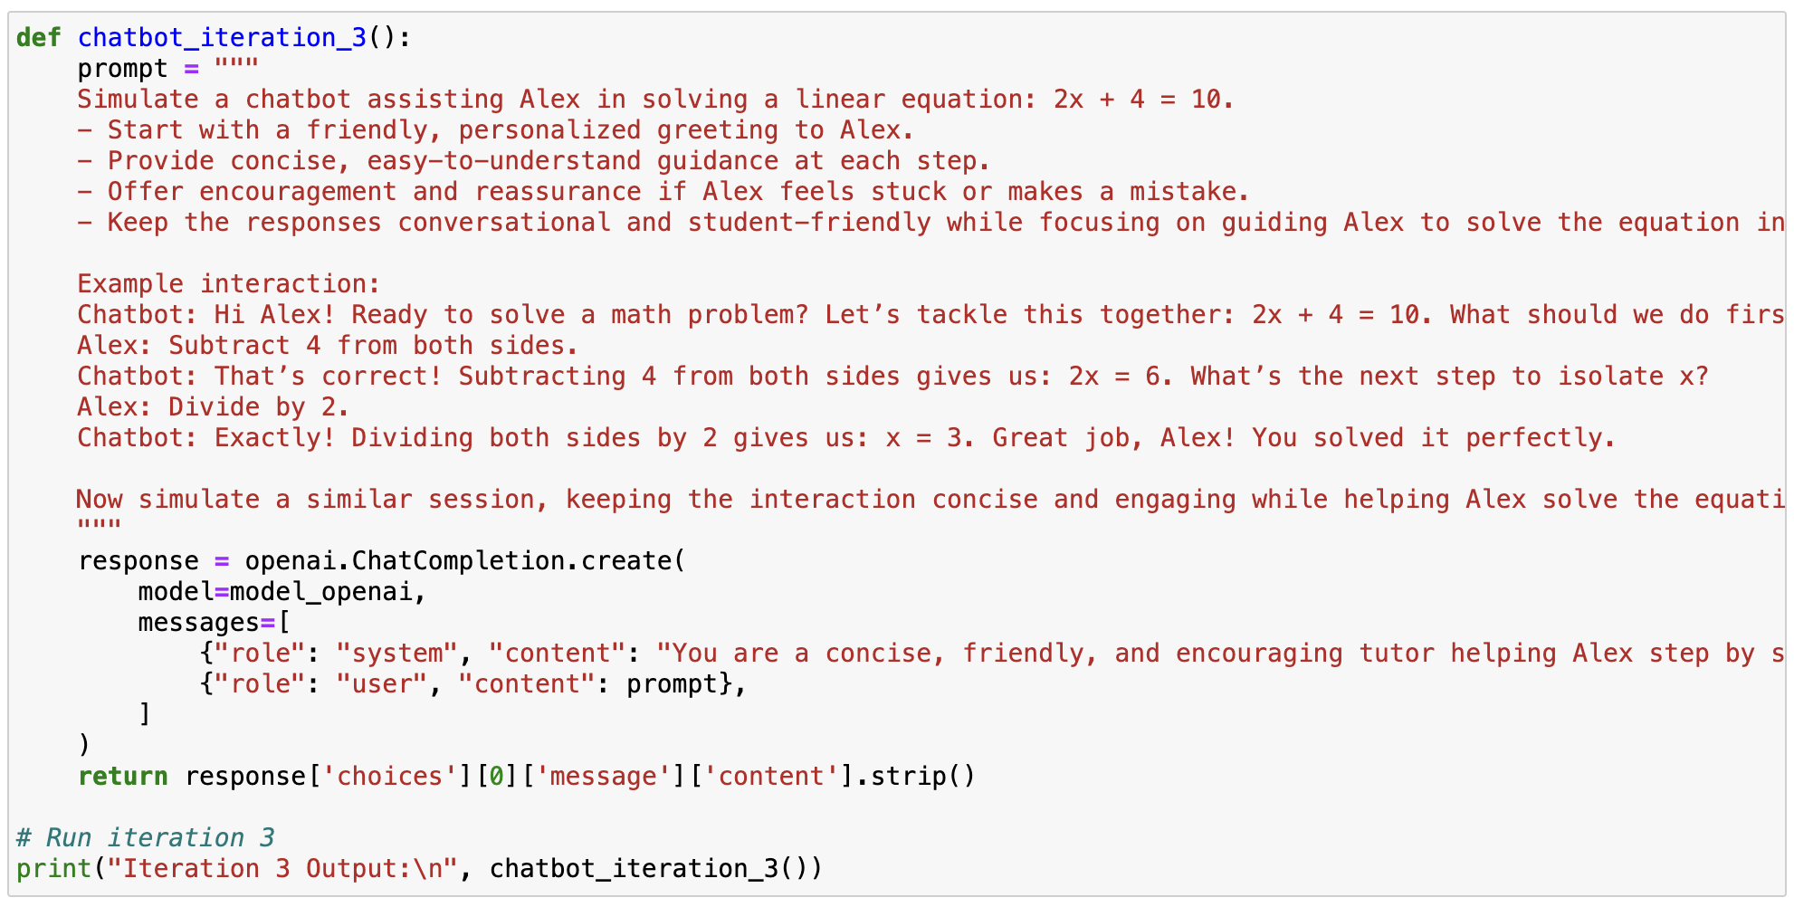

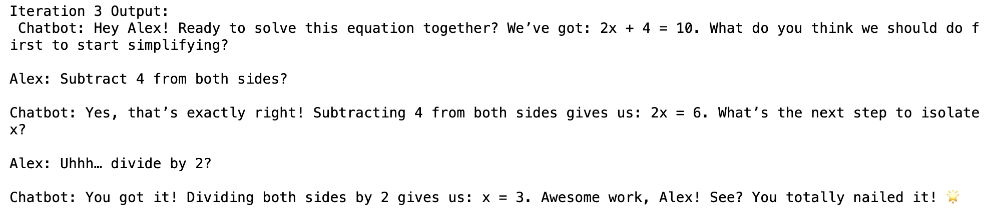

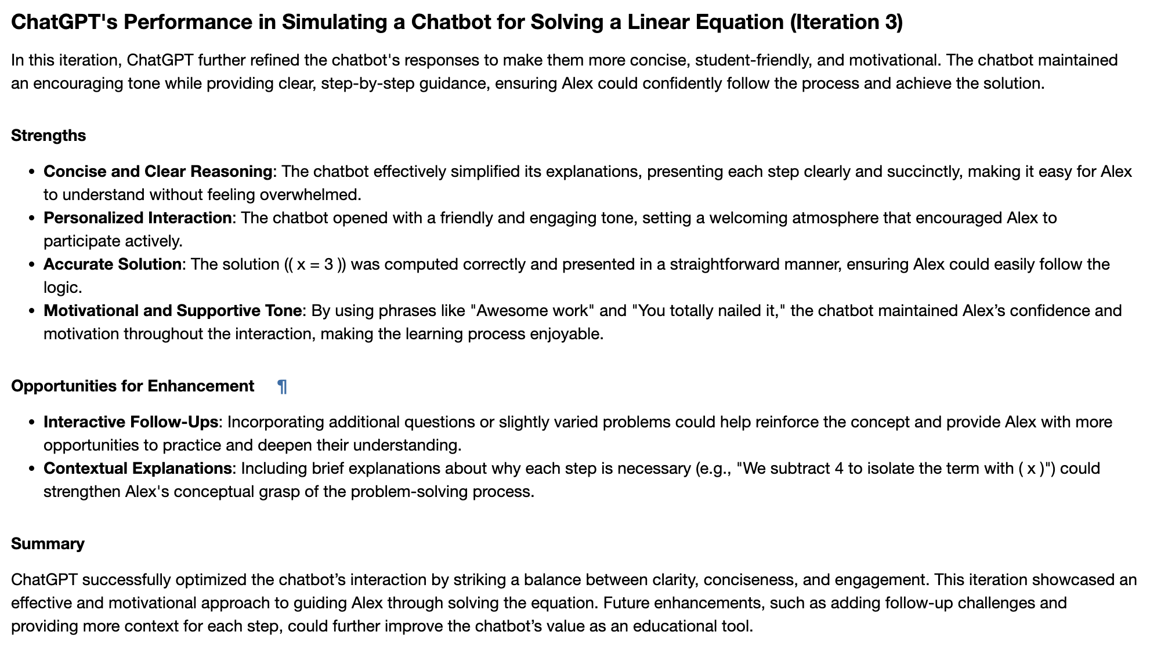

**Reflection on Challenges and Learnings**

The process of completing this assignment was both insightful and challenging, offering an opportunity to deepen my understanding of Generative AI and its applications in personalized education. This reflection highlights the challenges I encountered, the strategies I employed to overcome them, and the key takeaways from the experience.

**Challenges Encountered**

1. **Understanding Prompt Engineering**:  
   Crafting effective prompts for the OpenAI API was a significant challenge. Initially, the outputs were either too generic or not aligned with the intended objectives. This required multiple iterations to refine the prompts, ensuring that they were clear, structured, and specific. For instance, adding detailed instructions and examples in the prompts significantly improved the quality of the responses.
2. **Balancing Clarity and Conciseness**:  
   Striking the right balance between providing enough context in the prompts and keeping them concise proved to be tricky. Overly verbose prompts often led to redundant responses, while overly concise ones resulted in incomplete outputs. Learning to find the optimal level of detail was a key part of the process.
3. **Ensuring Contextual Relevance**:  
   Another challenge was ensuring that the AI-generated outputs were tailored to the specific requirements of a 10th-grade student (Alex). The initial responses sometimes included content that was either too advanced or overly simplified, requiring careful adjustments to the input criteria.
4. **Resource Recommendations**:  
   One recurring issue was the generation of generic resource recommendations. While the AI suggested platforms like Khan Academy and PhET Interactive Simulations, providing more specific resources (e.g., links to particular courses or books) was essential to enhance the practicality of the suggestions.
5. **Technical Integration**:  
   Configuring the OpenAI API and managing the API key securely were initial hurdles. Understanding the nuances of the openai.ChatCompletion.create method and its parameters required some experimentation and troubleshooting.

**Learnings and Takeaways**

1. **The Power of Prompt Engineering**:  
   This assignment reinforced the importance of well-crafted prompts in extracting high-quality responses from language models. I learned to be specific about the desired output, use structured instructions, and provide examples to guide the AI effectively.
2. **Iterative Improvement**:  
   The iterative nature of refining both the prompts and the AI’s outputs underscored the value of feedback loops. Each iteration provided insights into how the model interprets instructions and highlighted areas for improvement.
3. **Application of Chain-of-Thought Reasoning**:  
   Incorporating chain-of-thought reasoning in solving problems, such as physics equations, demonstrated how the AI can provide clear and logical step-by-step solutions. This approach was particularly effective in making complex concepts accessible to students.
4. **Personalization and Context Awareness**:  
   I gained a deeper appreciation for the model’s ability to generate personalized outputs when provided with detailed and relevant context. This is especially important in educational applications, where tailoring content to the learner’s needs can significantly enhance engagement and understanding.
5. **Ethical and Practical Considerations**:  
   Using AI responsibly, especially in education, requires thoughtful consideration of its limitations and potential biases. Ensuring that the outputs are accurate, contextually appropriate, and actionable remains a critical responsibility.

**Conclusion**

This assignment provided valuable insights into the practical applications of Generative AI in personalized learning. The challenges I faced pushed me to think critically about prompt design, contextual relevance, and user-centered design. The learnings from this experience will not only inform future assignments but also contribute to my broader understanding of leveraging AI to address real-world problems in education and beyond.